1. In this screenshot we can see how it calls all employees. Now it gives an empty array, as it is devoid of data.

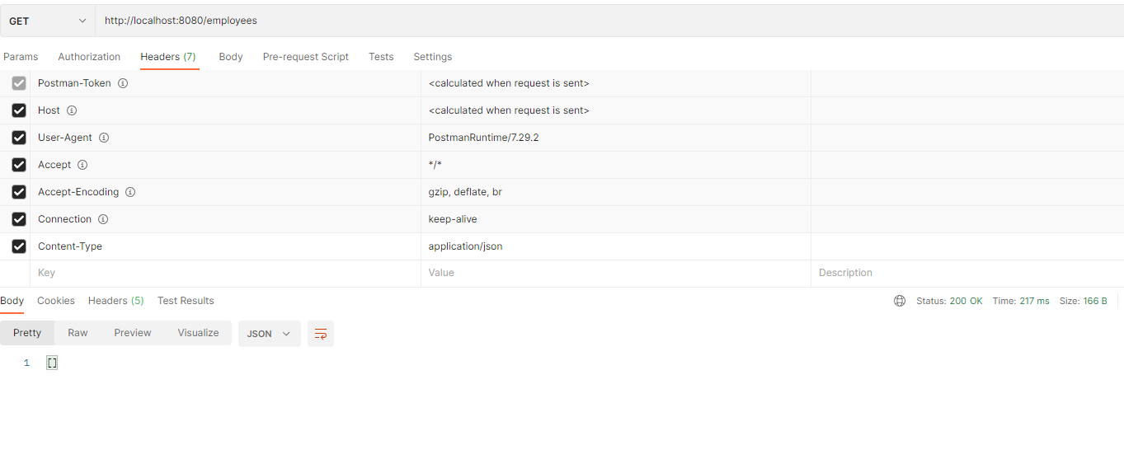

1. Posting a new user. It has been successfully created.

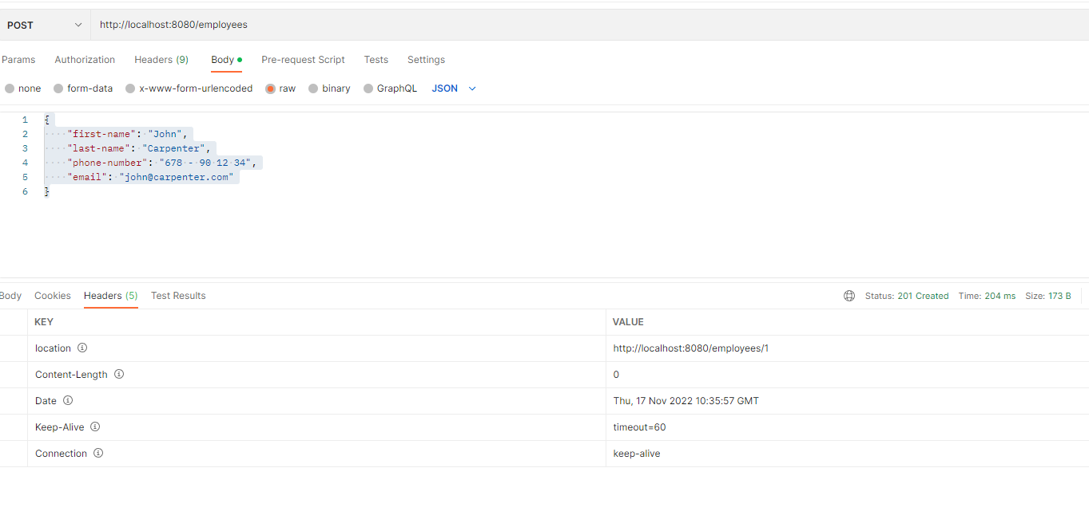

1. We try a GET to all employees and we get an array that is not empty anymore Graphical user interface, text, application, email

   Description automatically generated

4 - A GET to the specific employee returns correctly

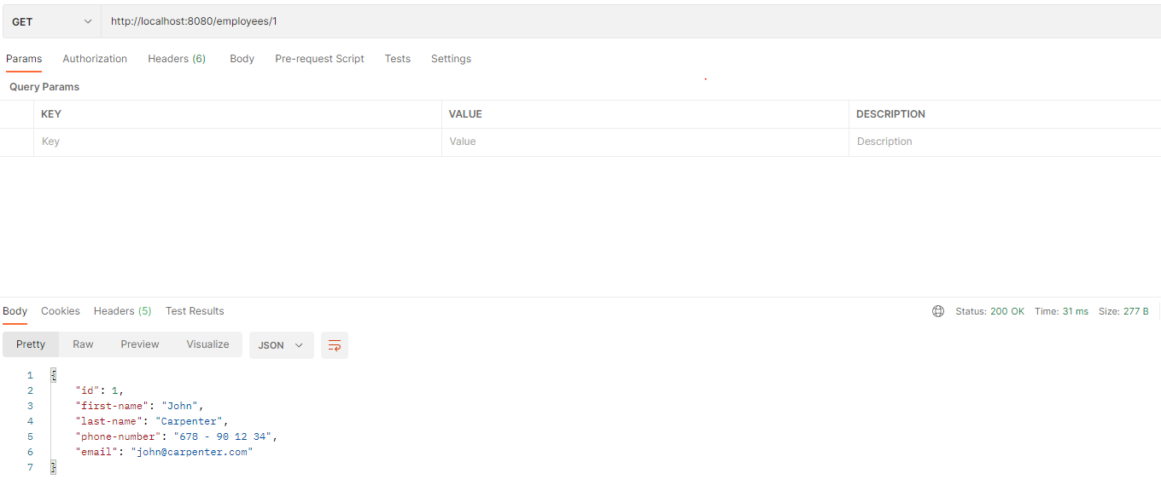

5 - We try a PUT with some modifications and it returns Accepted

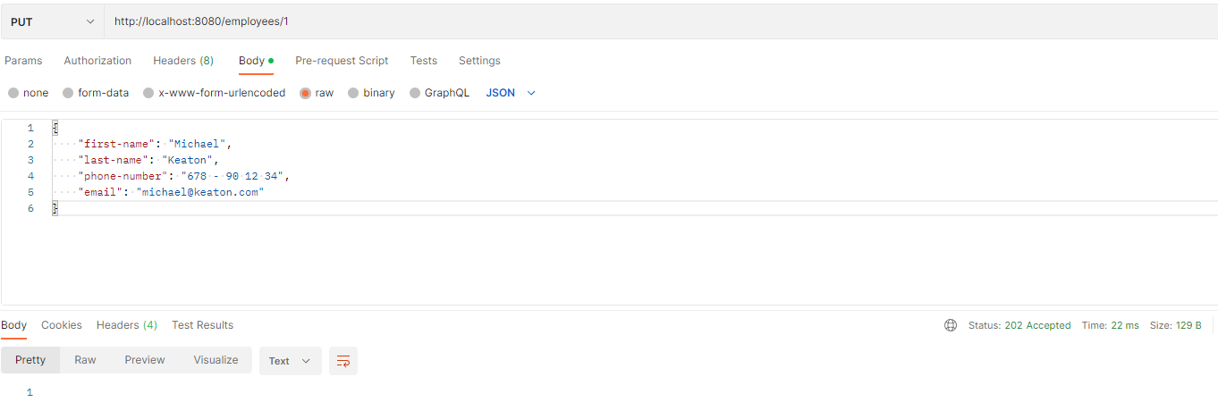

6 - A second GET returns the updated data

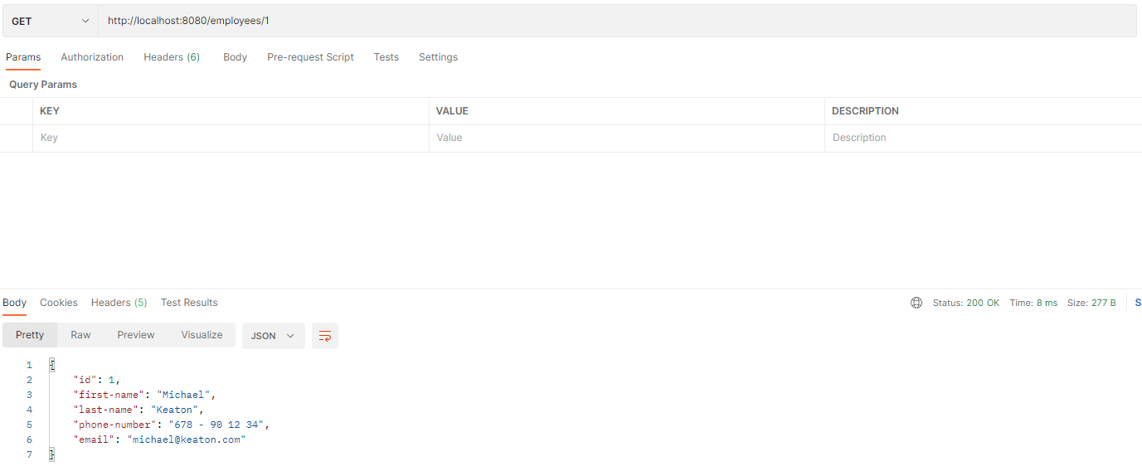

7 - We try a DELETE and it returns Accepted

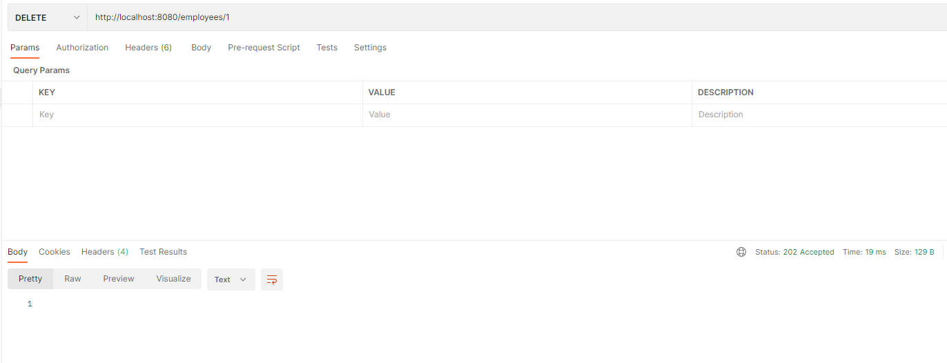

8 - A GET to all employees returns an empty array

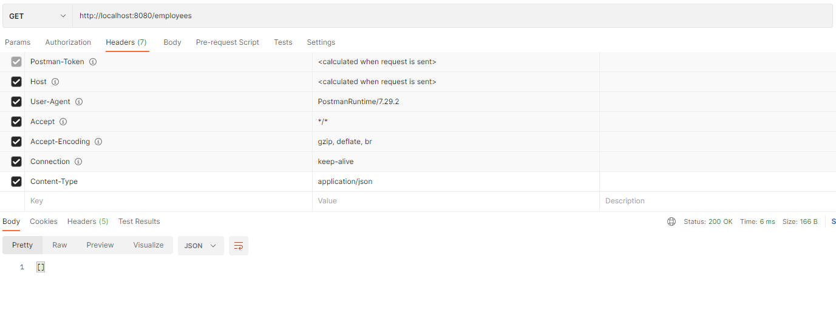

9 - A GET to the specific employee returns 404

